LOOK FOR INFORMATION October 21, 2020
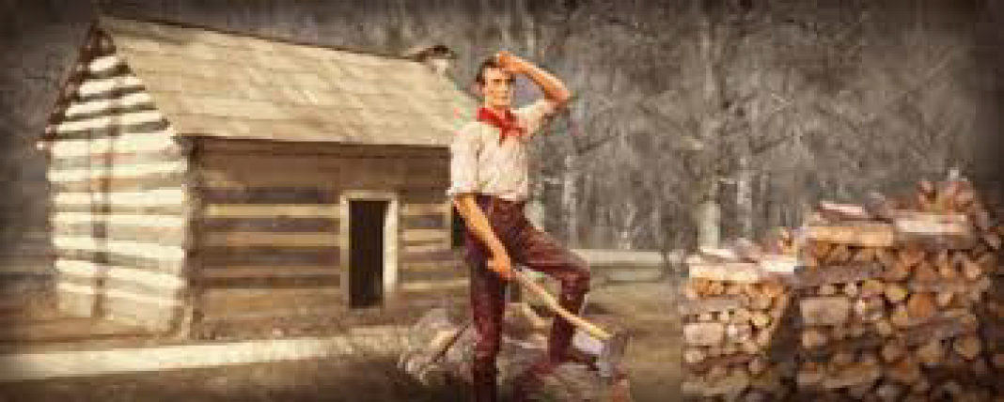
IN THE PICTURE:

WHO:

WHAT:

WHEN

TITLE: ____________________________________
________________________________________________________________________________________________________________________________________________________________________________________________________________________________________________________________________________________________________________________________________________________
WHERE

WHY

HOW:

